Quiz 1

Abdullah Dar

21L-7512 BSCS 3G

Code

[org 0x0100]

;21L-7512 Abdullah Dar BSCS 3G

jmp start

convertascii:

push bp

mov bp,sp

pusha

mov ax,0xb800

mov es,ax

mov di,2

mov ax,[bp+4]

mov cx,0

mov bx, 10

nextdigit:

mov dx, 0

div bx

;add dl,0x30

push dx

inc cx

cmp ax,0

jnz nextdigit

loop1:

pop bx

add bx,50 ; 50 all numbers will be +50 because starting 10 elkements of ascii have nothing to display on screen

;add bl,0x30

mov ax,0x0700

add bx,ax

mov [es:di],bx

add di,160

dec cx

jnz loop1

popa

pop bp

ret 2

start:

mov ax,0x7512

push ax

call convertascii

mov ax,0x4c00

int 0x21

Before Execution

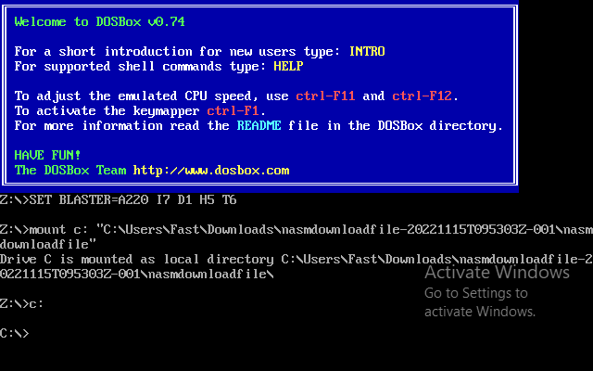

After Execution

